Ma'am here is my Excel assignment please accept iMa'am here is my Excel assignment please accept iMa'am here is my Excel assignment please accept i

# WORD EXERCISE

Mehedi Noor

Word task

Semester Fall,2022

Bachelor of Engineering, Information Technology

Centriaammattikorkeakoulu Oy

Content

1. Introduction 3
   1. Starting points and objectives ofthereport 3
      1. Hostcouncilmodel 4
      2. Cooperation between municipalities,ownboards 4
      3. Unification of interpretations and municipal rules as regional cooperation 4
2. The municipal association's report on municipal cooperation experiences .5
3. Regional environmental centers and municipal cooperation in building control 6
4. Cooperation models enabled by theMunicipalAct 8
   1. Hostcouncilmodel 8
      1. Generaldescription 8
      2. Investigation anddecisionprocess 9
   2. Raahe–Siikajokicooperation 9
   3. Cooperation between PielavesiandKeitele 10
   4. Loimaaregioncooperation 11
5. Purchase of official duties with agreementsbetweenmunicipalities 12
   1. Generaldescription 12
   2. Raahe region purchaseservice agreement 12

# INTRODUCTION

## Starting points and objectives of thereport

Building control authorities in municipalities have jurisdiction based on the Land Use and Building Act and Regulations and the Finnish Building Regulations.

According to Section 124 of the Land Use and Construction Act (MRL), "The task of the municipal building control authority is to monitor construction activities in the public interest and to ensure that construction is carried out in accordance with what is stipulated in the law." According to the Ministry of the Environment's Normtalkoot survey (2008), e.g. The practices of applying municipal planning building regulations are different in different municipalities. According to the survey, differences in interpretation may cause e.g. extra and unnecessary costs for housing construction. There are no uniform nationwide application guidelines for the regulations, so municipalities have had to find application solutions on a case-by-case basis. Greater uniformity of official practices was considered one of the starting points of this report.

It is also recorded in the government program that the need to develop building control and construction regulations will be assessed to ensure their uniform interpretations, construction quality and sustainable development. In small municipalities, the financial situation has led to personnel savings in construction supervision as well. Municipalities have arranged for building inspectors other tasks in the technical sector, environmental protection or housing, which, on the other hand, are not prohibited by the regulations. The task management model has been economically advantageous for municipalities. Due to the wide field of tasks, the building inspector cannot specialize in his own task area, and therefore customer service and expertise are not at the same level as they are in larger municipalities. The mutual cooperation of municipalities in handling official tasks was also considered as one of the starting points of this report.

One of the starting points of this report was to secure and develop the independence of the building control authority's activities. Managing the municipality's own construction issues in the same authority body and as a

building inspector has brought problems with accessibility. Official activity and task management relying on one person has not made it possible

## Host councilmodel

In the model, one municipality (the host municipality) produces the building control services defined in the agreement of the other municipalities participating in the cooperation. The model emphasizes the role of the host municipality as a service-producing unit. Other municipalities participating in contractual cooperation elect their representatives to the building control authority (board) of the host municipality.

## Cooperation between municipalities, ownboards

According to Section 21 subsection 2 of the Land Use and Construction Act, a municipality can, by contract, assign the task of building control to another municipality's office holder. Contract municipalities have their own boards. The appeal is determined according to the location of the place where the construction or operation is carried out.

## Unification of interpretations and municipal rules asregional cooperation

The unification of the rules is implemented as part of the Paras project , under the regional administration (regional model), or in another way as cooperation between municipalities. The purpose is to develop common procedures and harmonize rules and interpretations. The operational sector can also have other cooperation models, e.g. host municipality or purchasing service model, between smaller municipal groups.

# THE MUNICIPAL ASSOCIATION'S REPORT ONMUNICIPAL COOPERATIONEXPERIENCES

In the spring of 2008, during and alongside this survey, the Association of Municipalities conducted a survey of municipal cooperation experiences for five different regional areas. The report focused primarily on handling the tasks of the building control authority. All multi-municipal cooperation agreements for building control that were valid during the investigation were included:

* Eura, Säkylä and Köyliö multi-municipal cooperation in authorityareas
* Juva, Joroinen and Rantasalmi, multi-municipal cooperation in authority areas
* Raahe and Siikajoki couple cooperation in official areas, Raaheand Pyhäjoki and Raahe and Vihanti purchase agreements for official services
* Pielavesi and Keitele couple cooperation in officialareas
* Askola, Pukkila, Pornainen and Myrskylä multi-municipal cooperationin authority areas.

The investigation was carried out by collecting data from municipalities and interviews. Trustees, municipal managers, building inspectors, environmental managers and technical managers were chosen to be interviewed. There were 22 people interviewed. The interview was conducted in April-May 2008.

In the interviews, the backgrounds of the cooperation were initially explored, such as the start of the cooperation, the clarification of the cooperation and special reasons for starting the cooperation. In addition, the smoothness of the initiation and preparation of the cooperation was examined. In all survey areas, the start of cooperation between authorities is scheduled for the years 2003– 2005.

# REGIONAL ENVIRONMENTAL CENTERS AND MUNICIPAL COOPERATION IN BUILDINGCONTROL

Regional environmental centers are part of the national construction control system. Their task is to promote and guide the organization of the construction work of the municipalities and to supervise the consideration of the regulations related to the construction work. The work of the environmental centers focuses on monitoring the implementation of national land use goals in land use and construction, as well as providing legal and administrative expert assistance.

The environmental centers' decision-making authority includes deviation permits for coastal construction, deviation permits related to building protection and exceeding building rights. The environmental centers also monitor the decisions of the municipalities regarding planning needs solutions and other deviation permits as well as landscape work and demolition permits.

The task of the environmental centers is to be aware of the state of construction management and construction in their area, to support the municipalities in the development of their construction, to contribute to the compliance with construction regulations, to ensure that the municipalities' building control skills and resources are sufficient, and to ensure that the municipalities receive training and information guidance.

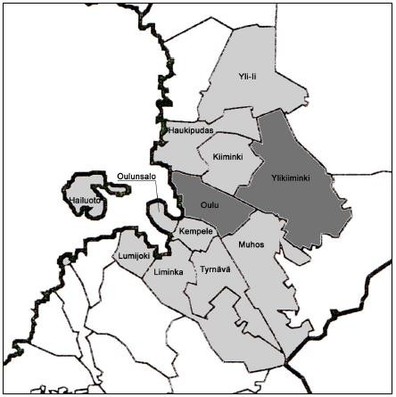

*FIGURE 1OULU REGION'S CONSTRUCTION SUPERVISION COOPERATION AREA*

# COOPERATION MODELS ENABLED BY THEMUNICIPAL ACT

The current legislation allows contractual collaboration or cooperation, which may concern, for example, the establishment of a joint office and the sharing of the resulting costs (Municipal Act § 76 subsection 2), the performance of official duties as purchasing services (Municipal Act § 76 subsection 3) or the establishment of a joint institution (Municipal Act 77 §). Joint office of municipalities means an arrangement where the office holder holds office in two or more municipalities. One of the municipalities is responsible for the employer's obligations, the office holders are employed by that municipality.

In the 2000s, several models of inter-municipal cooperation in construction supervision have been introduced in different parts of Finland, contract-based models, mainly with the host municipality principle and the purchasing service principle. More informal cooperation between authorities is implemented in several regional municipalities, with the aim of harmonizing rules and operating methods and increasing information sharing. All cooperation models aim at improving customer service and making the work of building inspectors easier. In the longer term, cooperation also has its own effect in shaping public opinion to accept the position of building control as an independent actor in the development of the construction industry. The cooperation models made possible by the Municipal Act and their implemented example cases are presented below.

## Host councilmodel

## General description

A joint institution is one of the possibilities offered by the Municipal Act for organizing the joint activities of municipalities. When a municipality performs a service on behalf of one or more municipalities based on a contract, the municipalities can agree that the other contracted municipalities will select part of the members for the municipality responsible for the tasks. to the institution of the host country. This host municipality can also be referred to as the

responsible municipality or the central municipality. A joint institution can bea board, a board of directors or a committee that belongs to the organization of one contracting authority. (Association of Finnish Municipalities2006).

## Investigation and decisionprocess

In the 1st phase of the investigation, when the municipalities have agreed in principle on cooperation and the clarification of its conditions and goals, the municipalities set up an investigation working group that includes office holders from each participating municipality and appoint a leader for the project, who can be a consultant or an office holder. In terms of the success of the work, it is important that the group includes sufficiently influential trustees from the municipalities, who have the political support of the municipalities behind them. In preparation, it is good to cooperate with the regional environmental center.

The Association of Municipalities advises and guides when requested. Working groups can be appointed to assist the survey work group, which do the actual survey work and report the results of their work to the steering group.

Examples of implemented municipal cooperation solutions

## Raahe–Siikajoki cooperation

There are 22,400 inhabitants in the city of Raahe, 5,827 in the municipality of Siikajoki.

|  |  |
| --- | --- |
| Place | Population |
| Raahe city | 22 400 |
| Siikajokimuncipality | 5 827 |
| Total | 28 227 |

*TABLE 1 RAAHE AND SIIKAJOKI POPULATION NUMBERS.*

The combined land area of the municipalities is 1572 square kilometers. Both are located on the shores of the Pärämere. The city of Raahe and the municipality of Siikajoki have agreed, based on Section 21 of the Land Use and Construction Act, to manage building control tasks and to manage

environmental protection tasks and tasks according to the Land Materials Act in cooperation since the beginning of 2007.

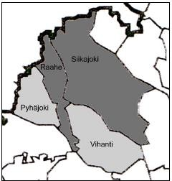

*FIGURE 2RAAHE REGION'S COUPLE COOPERATION AREA, WHICH INCLUDES PYHÄJOKI AND VIHANTI WITH PURCHASE SERVICE AGREEMENTS*

## Cooperation between Pielavesi andKeitele

The municipalities of Pielavesi and Keitele agreed in the framework agreement on municipal cooperation that in addition to environmental protection, building control in the municipal area will be implemented as municipal cooperation from the beginning of 2005. The environmental protection tasks in Keitele had already been handled by the Environmental Protection Secretary of Pielavesi as a purchasing service, and the same arrangement was introduced for building control on November 1, 2004.

In the next step, building control and environmental protection were combined for Pielavede to be handled by one joint board with former personnel. Both municipalities elect 5 members to the joint board. The chairman is elected from Keitele's shop stewards, the vice chairman comes from Pielaveti. The board belongs to the administrative organization of Pielavesi municipality. The personnel consists of the building inspector in both municipalities, the secretary of environmental protection, the clerk of building control and clerks in both municipalities. The main office is located in Pielavedi, there is a branch office in Keitele. (PielavesenKHall 2004) A simple and clear system has been tried for the distribution of costs. The distribution is based on the population of

municipalities at the end of the previous year. The cost distribution was changed for the office staff from the beginning of 2008. ( KeileenKHall 2007)

## Loimaa region cooperation

The building inspections of the city of Loimaa and the municipalities ofAlastaro, Mellilä and Oripää belong to Turku region's construction lover’s association. In 2007, the Loimaa region made a proposal between the aforementioned municipalities for joint environmental management in the Loimaa region. The combined population of the municipalities is approximately 18,700 and the surface area is 958 km2. Later that year, Loimaa, Alastaro and Mellilä made a decision to merge municipalities and the proposal was not implemented. The proposed model was the so-called host municipality model, in which the host municipality would be the city of Loimaa, to which the personnel would be transferred. The environmental action would be administratively its own department, the head of which would be directly subordinate to the mayor. In the city of Loimaa, a joint, 7-person environmental committee of the municipalities would be established, where all municipalities would have a representative according to the size of the municipality. The management model according to the proposal included building control, land control, environmental protection, housing loan and assistance matters, contingency planning and occupational health andsafety.

Already in 1993, the first cooperation study on building control, soil control and repair advice had been done in the area. An actual cooperation agreement was not created, but as a result of the investigation, an even closer cooperation between the officials began. Almost identical building regulations and building control fees were prepared in cooperation with the municipalities.

# PURCHASE OF OFFICIAL DUTIES WITHAGREEMENTS BETWEENMUNICIPALITIES

## General description

The Municipal Act allows the municipality or its authority to agree on assigning a task stipulated in the law to another municipality's office holder with official responsibility. The provision also applies to statutory tasks, tasks requiring the use of public authority. The corresponding provision is in the Land Use and Construction Act, which entered into force on January 1, 2000, in section 21, subsection 2, according to which a municipality can assign the task of building control to another municipality's office holder by contract. Agreements can also be made on official tasks, their preparation, presentation, decision-making and supervision. When an agreement is made that the office holder of a municipality also handles the official duties of another municipality, the office holder acts with official responsibility also when performing these duties. An agreement can also be made for part of the tasks of an administrative branch, e.g. a municipality buys a resource from another municipality for inspections during construction. (Association of Finnish Municipalities 2006). Each contract municipality has a body of shop stewards acting as a building committee. The rectification request regarding the administrative decision is processed by the building control institution of the municipality where the construction islocated.

The purchase of tasks requires a written agreement, which must be approved by the municipalities that are parties to the agreement in the institution to which decision-making falls according to the law or 26 management rules. As far as the reorganization of the administration is concerned, the matter must be decided by the council. Provisions on the organization of administration are given in the administrative rules and the management rules.

## Raahe region purchase serviceagreement

There are 22,433 inhabitants in the town of Raahe, 5,832 in the municipality of Siikajoki, 3,367 in the municipality of Pyhäjoki and 3,272 in the municipality of Vihanni.

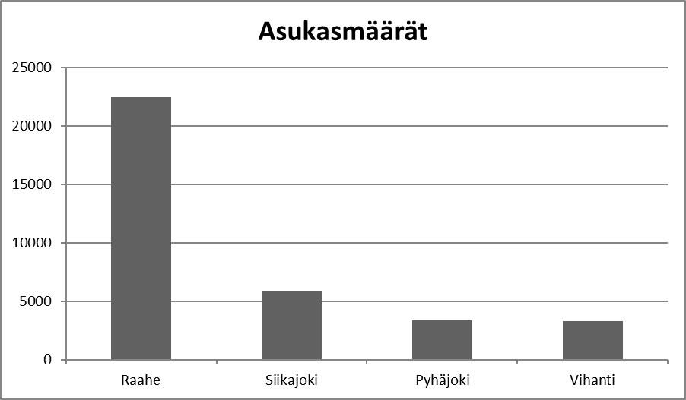

*CHART 1 THE POPULATION OF RAAHE, SIIKAJOKI AND VIHANTI*

The combined land area of the municipalities is approximately 3,480 square kilometers. Pursuant to Section 21 of the Land Use and Construction Act, the city of Raahe and the municipality of Siikajoki have been partnering in the management of building control tasks as well as environmental protection tasks and tasks in accordance with the Land Materials Act since the beginning of 2007. Siikajoki terminated the contract at the end of 2007 so that the current contract ends on December 31, 2008. In addition, the municipality of Vihanni has a purchase service agreement with the city of Raahe for the performance of the duties of a building inspector for the year 2008, and the municipality of Pyhäjoki for the performance of the duties of a building inspector and the duties of the environmental protection secretary from 1 October 2007 to 31 December 2008.

During 2008, the four municipalities of the Raahe region have negotiated a new cooperation agreement, which will enter into force on January 1, 2009. The agreement concerns the management of construction supervision tasks,

environmental protection tasks, preparation and control tasks according to the Land Resources Act, and other tasks related to environmental protection.